**Bluetooth Controlled Car**

**Component Required:**

**Robot Car Chassis:**

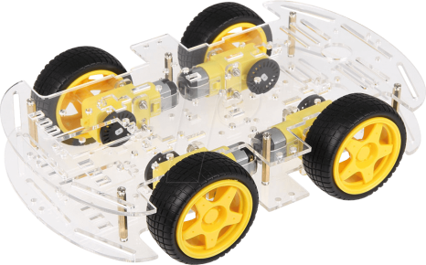

**L298N Motor Driver:**

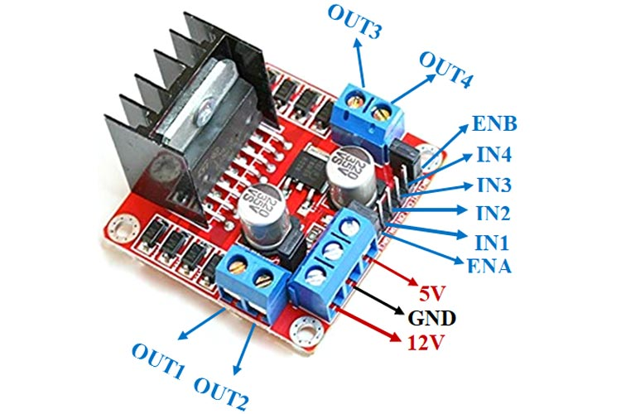

**Arduino-Uno:**

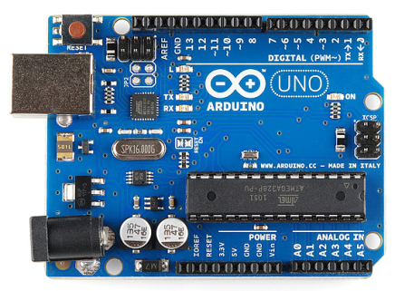

**Battery:**

Use battery more than 5V(up to 12v). you can buy batteries and do series connection to get more voltage.

**Bluetooth Module HC 05:**

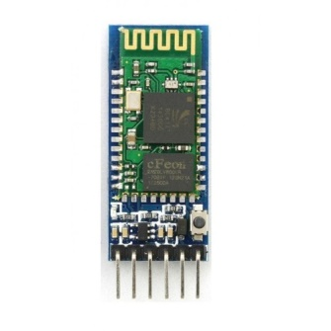

**Bluetooth RC Car:**



Install this application on mobile to control the car.

**Architecture:**

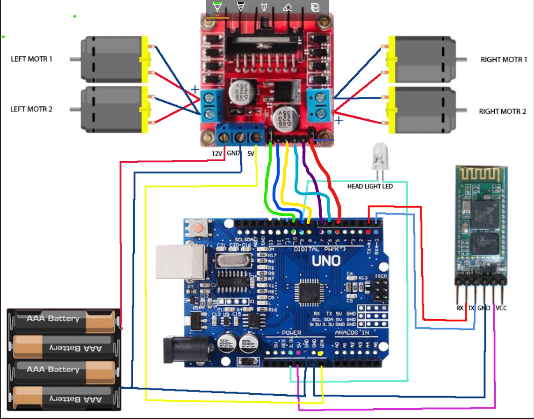

**NOTE:** First of all remove two jumpers from motor driver and you will get two enable pins so there will be six pins in motor driver then connect the pins as shown in above diagram.